**Directives**

Creating a directive

* Change the color of the tag.

### 

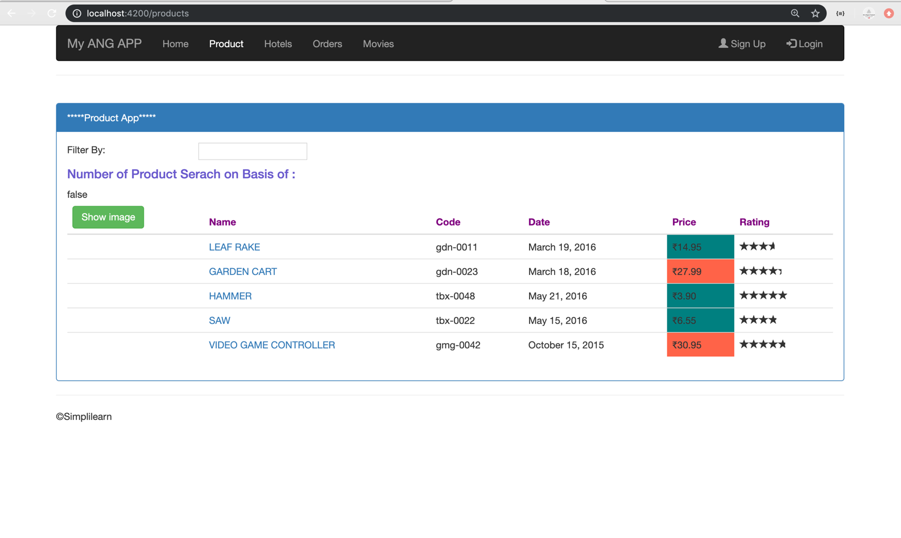

* Open Visual Studio Code
* Add the color property with the help of *ElementRef*.

// Required services for custom directives

import { Directive, ElementRef, Renderer2 } from '@angular/core';

@Directive({

  selector: '[appChangeColor]' // Directive selector

})

export class ChangeColorDirective {

  constructor(elem: ElementRef, renderer: Renderer2) {

    renderer.setStyle(elem.nativeElement, 'color', 'olive');

  }

}

Declaring the directive

* Declare the directive in declaration array.

import { ChangeColorDirective } from './ChangeColor.directive';

@NgModule({

    imports: [

        SharedModule,

        AppRoutingModule

    ],

    declarations: [

        ChangeColorDirective,

        ProductComponent,

        MyUpperPipe,

        DiscountPipe,

        ProductSearch,

        ProductDetailComponent

    ],

Adding the directive as a property

* Add the created directive as a property.

 <h4 appChangeColor>Number of Product Serach on Basis of {{userInput}}:</h4>

**Output:**

